# Media Analysis - ChatGPT_ AI grows more powerful as we become more predictable _ Arab News

## Short Summary

The article is about how the rapid adoption of ChatGPT, a large language model owned by OpenAI, highlights both its impressive capabilities and its limitations, as well as the growing concern that human behavior is becoming increasingly predictable in a world dominated by algorithms.

## Summary

Here are four bullet points summarizing the article:  
  
• The adoption rate of ChatGPT, an artificial intelligence large language model owned by OpenAI, is unprecedented, with one million unique users within five days of its release.  
• Despite the rapid growth in AI tool usage, the technology still lacks the fundamental ability to reason and instead relies on analyzing massive data sets to produce content based on guesses about trends in the data.  
• Human behavior has become increasingly predictable due to nearly two decades of internet and smartphone usage, allowing algorithms like those used by OpenAI to accurately guess what users are thinking or looking for in an answer.  
• The author argues that while AI tools have potential benefits, such as increasing efficiency, they should not be seen as a replacement for human intelligence, and companies and governments rushing to adopt them should consider more incremental approaches.

## Question 1

The text frames the public discussion about ChatGPT as follows * The adoption rate of ChatGPT is staggering and unprecedented, with many comparing it to the pace of adoption of other groundbreaking technologies like the iPhone. * There are concerns about the limitations of AI tools, particularly their inability to reason accurately, as pointed out by linguist Noam Chomsky. * The text also highlights the issue of human behavior becoming increasingly predictable due to algorithms shaping what people read and digest online. Some metaphors that keep cropping up in the text include * Turning the world upside down implying a rapid and profound change * ChatGPT signals the proper start of the AI age implying a new era or paradigm shift * Locking in or foreclosing future contestation implying a loss of freedom or agency

## Question 2

The article highlights that several perspectives and aspects of the topic are being widely covered * The rapid adoption rate of ChatGPT and its potential implications on society. * Concerns about the increasing predictability of human behavior due to internet and smartphone usage. * Limitations of AI tools, particularly their inability to reason and balance creativity with constraint. * Ethics debates surrounding AI development, such as the lack of ethics parameters in AI development. However, some aspects are being ignored * The potential benefits of AI tools in collaboration with humans, rather than replacing them. * The need for a more incremental approach to AI incorporation, rather than a complete takeover or outsourcing.

## Question 3

Not mentioned

## Question 4

The final message of the article is that while AI tools like ChatGPT can be useful, they cannot replace human intelligence and should be used collaboratively, not as a complete takeover.

## Sentiment

The sentiment is 0.0

## Entities

AI, Copyright Syndication Bureau, JOSEPH DANA, TikTok, Joseph Dana, OpenAI, stu, Googles, The New York Times Whereas, Gmail, Noam Chomsky, iPhone, ibnezra lang, Chomsky, Twitter ibnezra https twitter.com, Exponential View, ChatGPT-4 https cdn.openai.com, Arab News

## Highlights

#fb5b89: 43

#69aff0: 18

#7cc867: 16

#f9cd59: 20

## Wordcloud for #fb5b89 Highlights

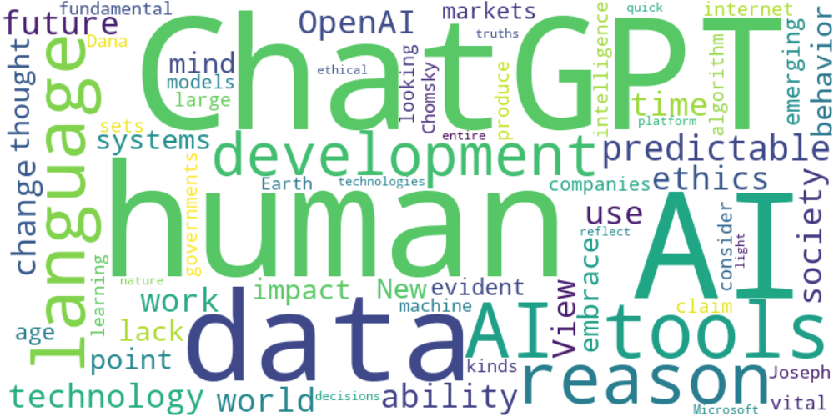

Top 10 words:

- AI: 14

- ChatGPT: 10

- human: 8

- tools: 7

- data: 6

- reason: 5

- language: 5

- predictable: 5

- future: 4

- work: 4

## Wordcloud for #69aff0 Highlights

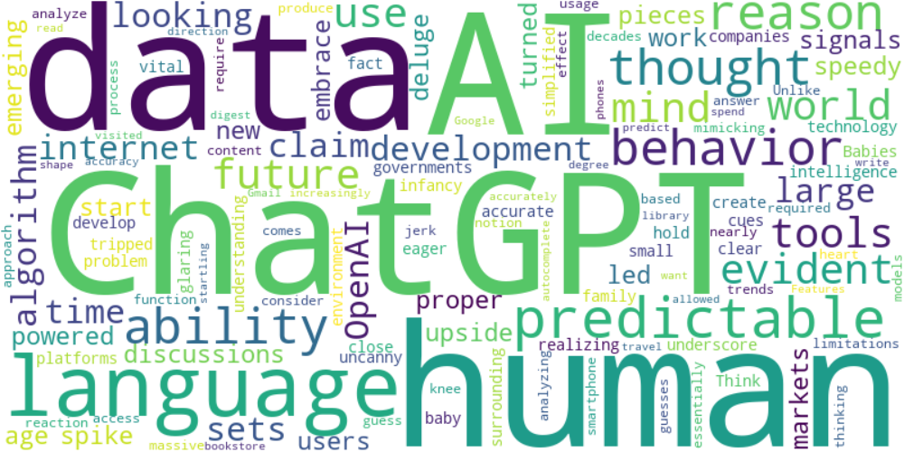

Top 10 words:

- AI: 6

- ChatGPT: 6

- data: 6

- human: 5

- language: 5

- predictable: 4

- reason: 3

- ability: 3

- behavior: 3

- thought: 2

## Wordcloud for #7cc867 Highlights

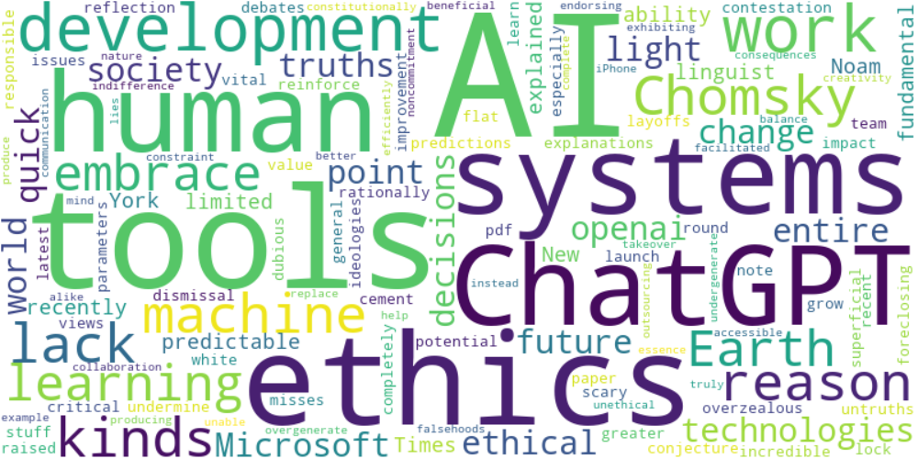

Top 10 words:

- AI: 7

- tools: 5

- ethics: 4

- systems: 3

- ChatGPT: 3

- work: 3

- lack: 2

- reason: 2

- Chomsky: 2

- kinds: 2

## Wordcloud for #f9cd59 Highlights

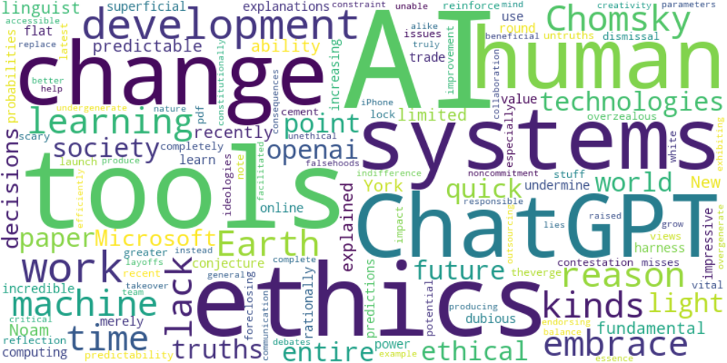

Top 10 words:

- AI: 7

- tools: 5

- ethics: 4

- systems: 3

- change: 3

- ChatGPT: 3

- work: 3

- lack: 2

- reason: 2

- Chomsky: 2